# **PRACTICE REPORT**

# **WEB PROGRAMMING LAB WORKS**

# **MODULE 8**

# **“Javascript”**



**Assembled by:**

# **ONIC AGUSTINO**

# **L200234275**

**X**

**PROGRAM STUDI TEKNIK INFORMATIKA**

**FAKULTAS KOMUNIKASI DAN INFORMATIKA**

**UNIVERSITAS MUHAMMADIYAH SURAKARTA**

**TAHUN 2024/2025**

**PRACTICE**

1. **Attempt 1 (Javascript)**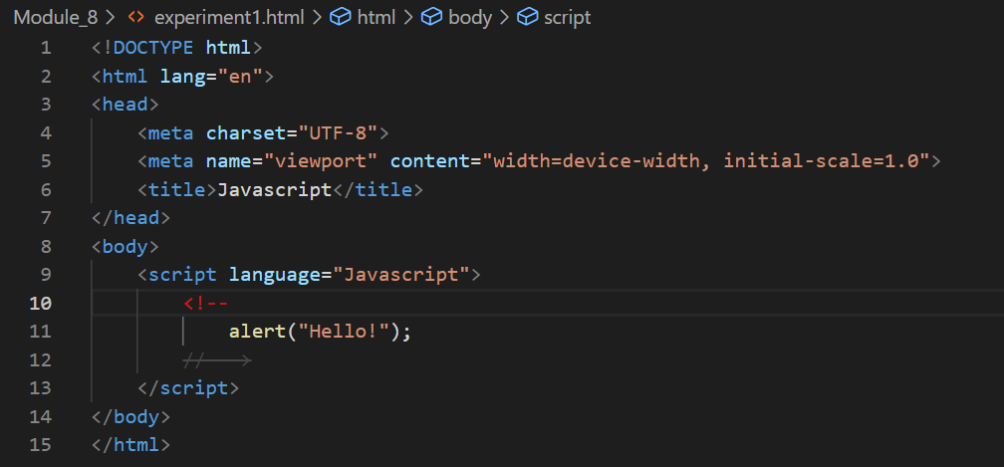

Picture 1.1 The Code.

(Explanation)

The code provided is the basic structure of a webpage using HTML, where the <head> element contains important information such as character encoding (UTF-8) and the page title. Inside the <body>, there's a <script> element that includes JavaScript code. The command alert("Hello!"); is used to display a pop-up message saying "Hello!" when the page loads. The comments in the code use the syntax <!-- ... -->, which is actually unnecessary in JavaScript since it has its own comment notation (//).

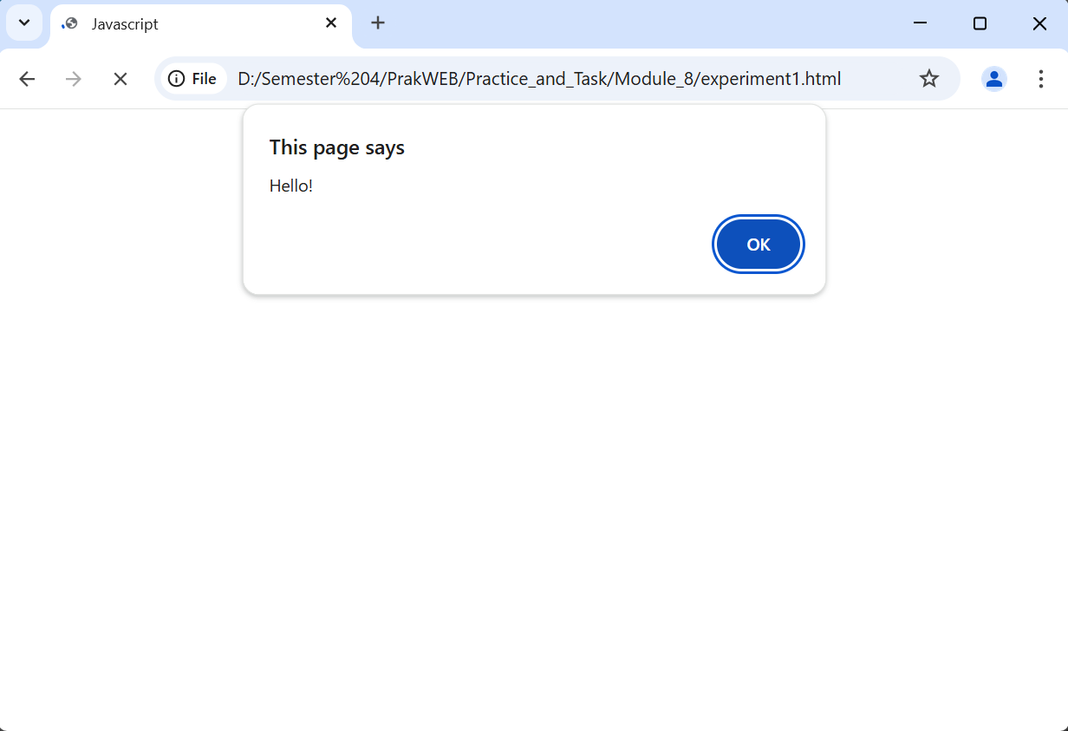

Picture 1.2 The Output.

1. **Percobaan 2 (MouseOver)**

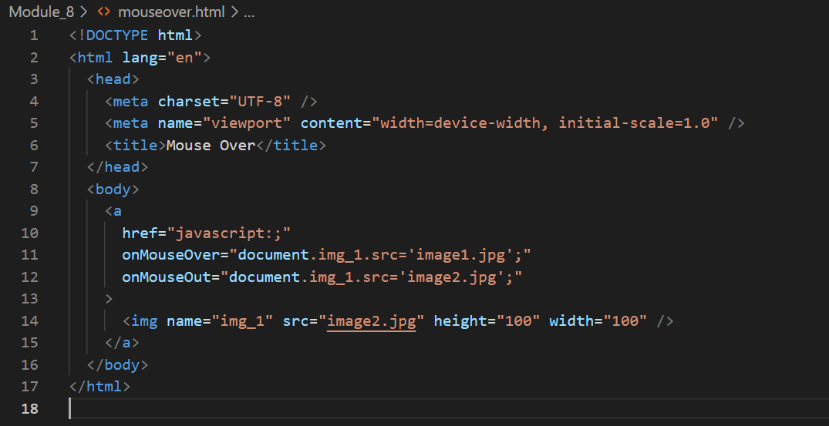

Picture 2.1 the code.

(Explanation)

This HTML code creates an interactive image effect using JavaScript. It defines a hyperlink (`<a>` tag) that contains an image (`<img>` tag). When the user hovers over the link, the image changes to `image1.jpg` through the `onMouseOver` event. When the user moves the cursor away, the image reverts to `image2.jpg` using the `onMouseOut` event. The `href="javascript:;"` prevents the link from navigating anywhere when clicked. Additionally, the image is assigned the name `img_1`, allowing JavaScript to manipulate its `src` attribute dynamically.

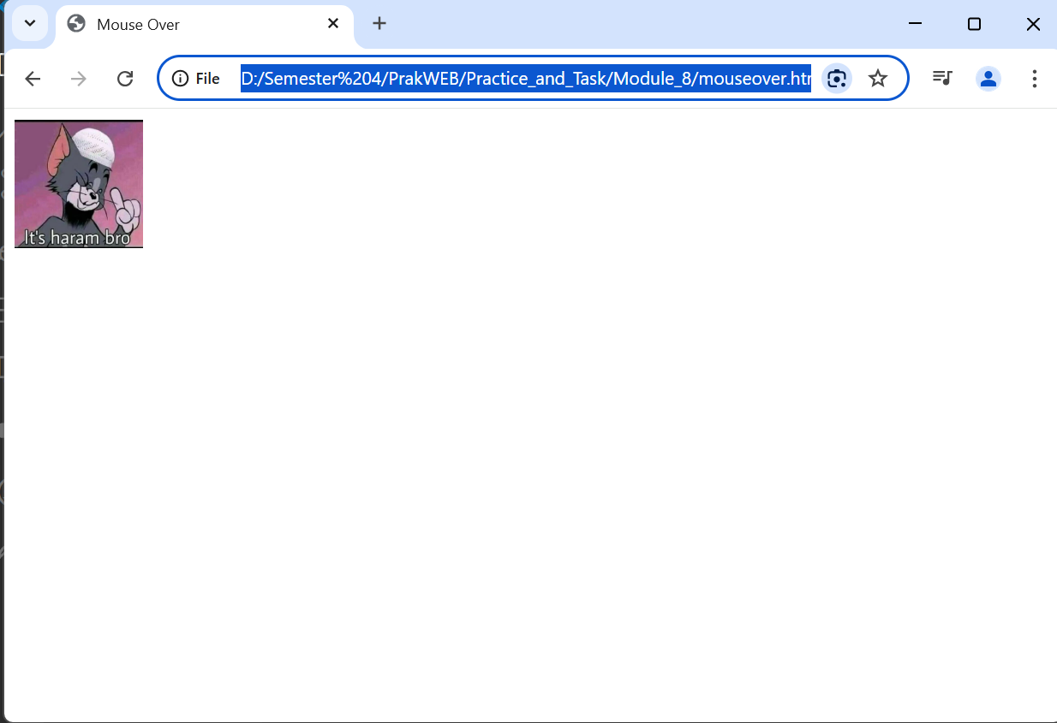

Picture 2.2 the output.

1. **Trial 3 (Character Counter)**

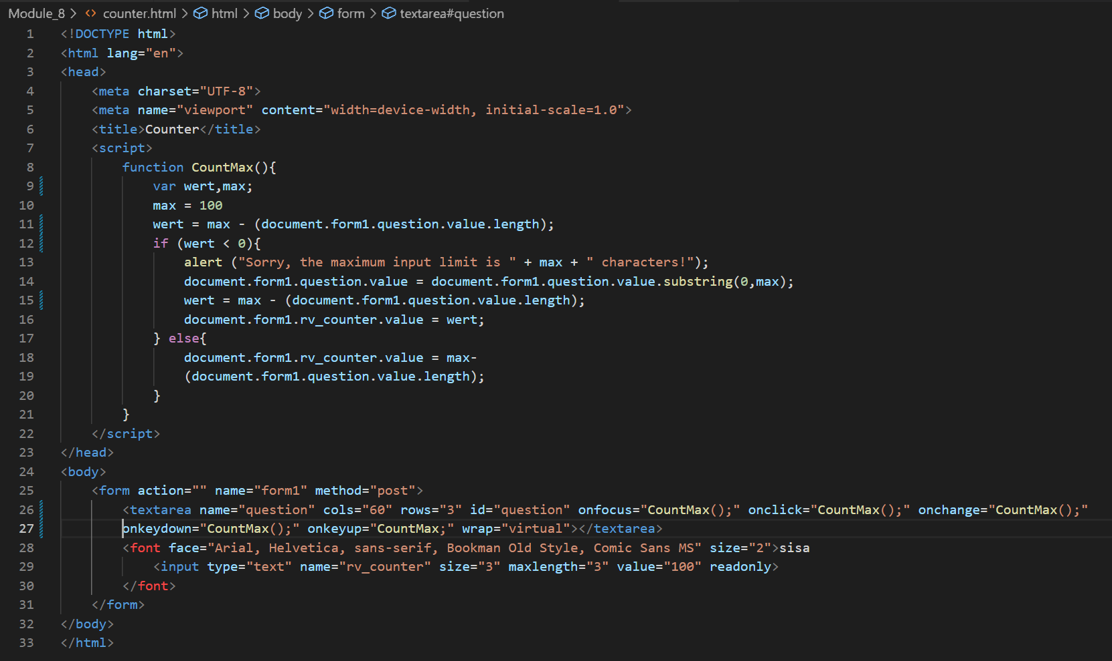

Picture 3.1 the code.

(Explanation)

This HTML code creates a simple character counter for a <textarea> input field using JavaScript. The CountMax() function sets a maximum limit of **100 characters** and dynamically updates the remaining count. Whenever the user types in the text area, various event listeners (onfocus, onclick, onchange, onkeydown, onkeyup) trigger the function to track the input length. If the user exceeds the limit, an alert warns them, and the excess characters are removed automatically. The remaining character count is displayed in a readonly <input> field to inform the user of the number of characters they can still enter. However, there is a small error: the onkeyup event should call CountMax() instead of CountMax;, as the latter lacks parentheses and won't execute the function.

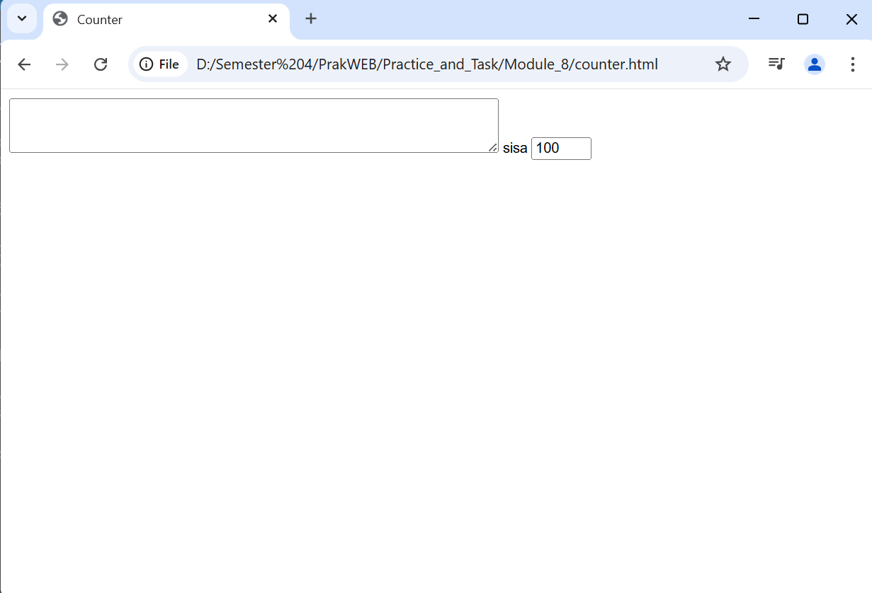

Picture 3.2 the output.

1. **Experiment 4 (Simple Calculator)**

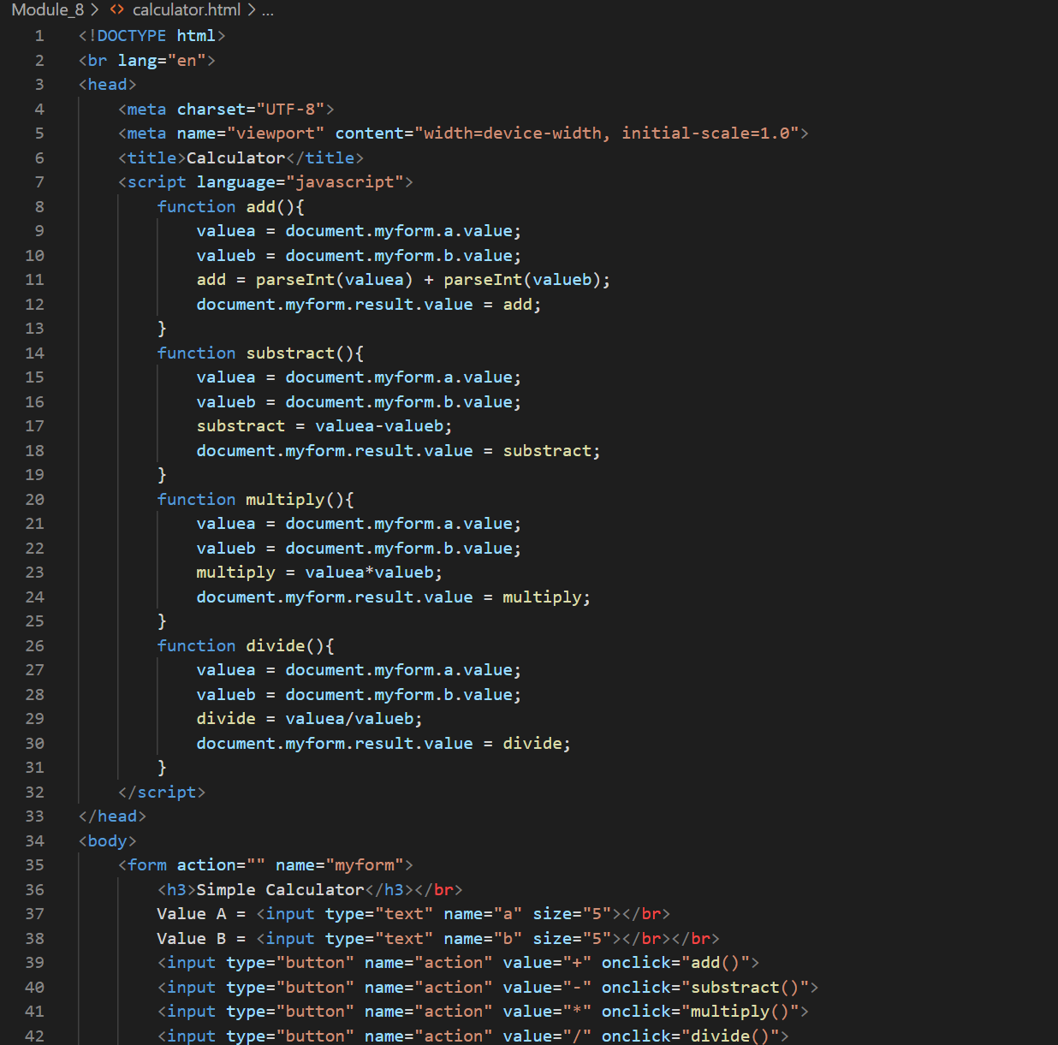

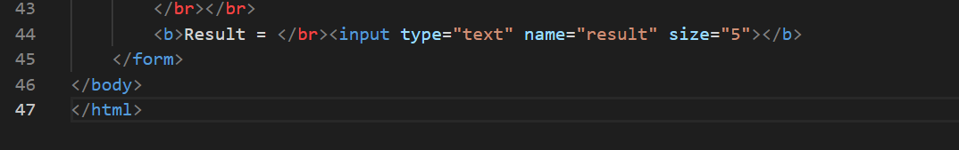

Picture 4.1 the code.

(Explanation)

This code creates a simple calculator using HTML and JavaScript. The user enters two values (Value A and Value B) into input fields, and clicking one of the operator buttons (+, -, *, /) triggers a corresponding function that performs the calculation. Each function retrieves the input values, processes them using mathematical operations, and displays the result in an output field.

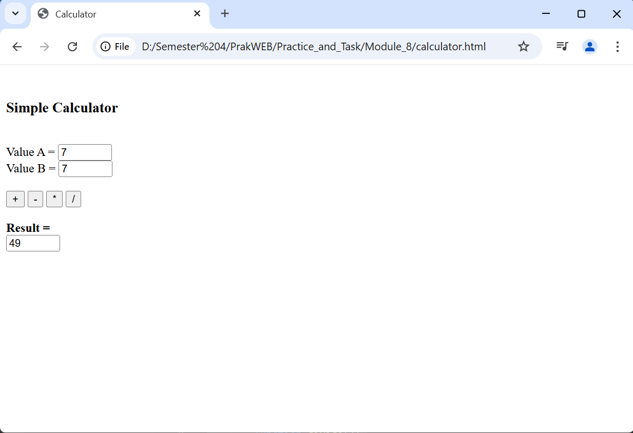

Picture 4.2 the output.

**ASSIGNMENT**

1. **Create a simple decision making application using JavaScript that calculates values with the following conditions:**

**If Value 0-20 = E**

**If Value 21-40 = D**

**If Value 41-60 = C**

**If Value 61-80 = B**

**If Value 81-100 = A**

(Screenshot script in the text editor)

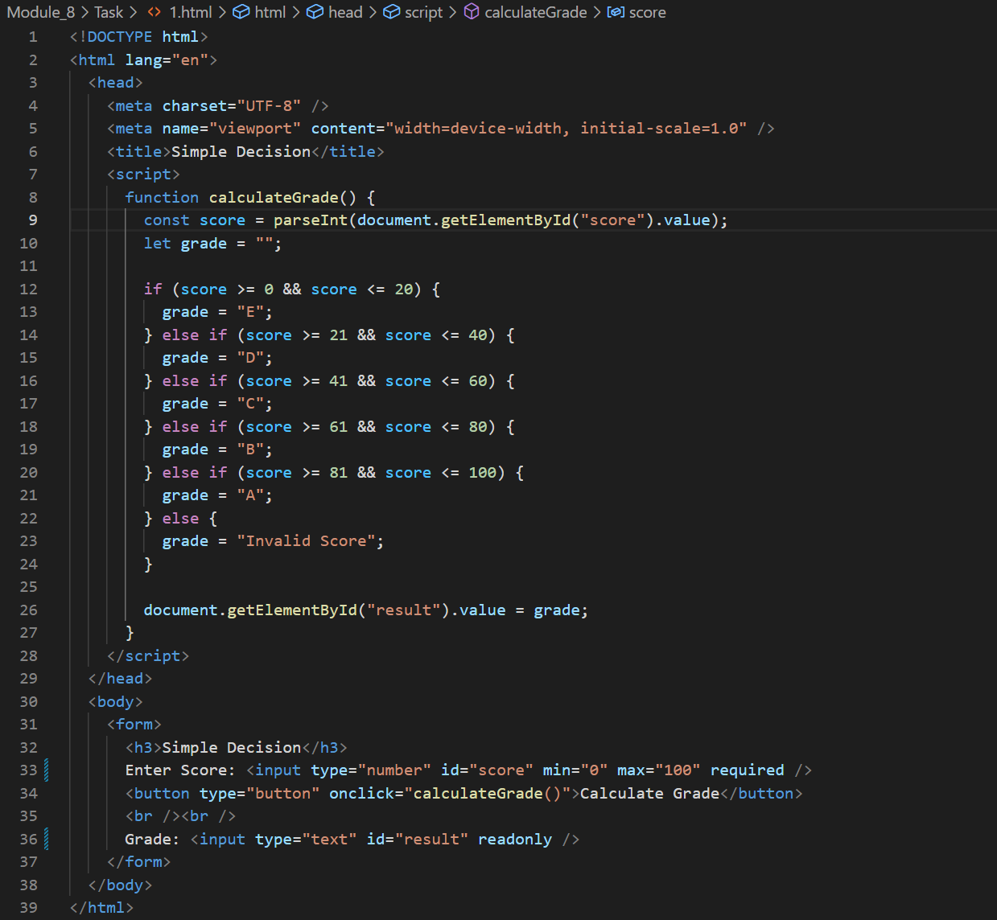

Picture 1.1 assigment the code

(Explanation)

This HTML and JavaScript code provides a simple grade calculator based on a user's input score. It takes a numeric value from an input field and determines the corresponding grade (A, B, C, D, or E) using conditional statements inside the calculateGrade() function. If the score falls outside the valid range of **0 to 100**, the function assigns "Invalid Score" as the grade. The result is then displayed in a read-only input field.

(Screenshot Output)

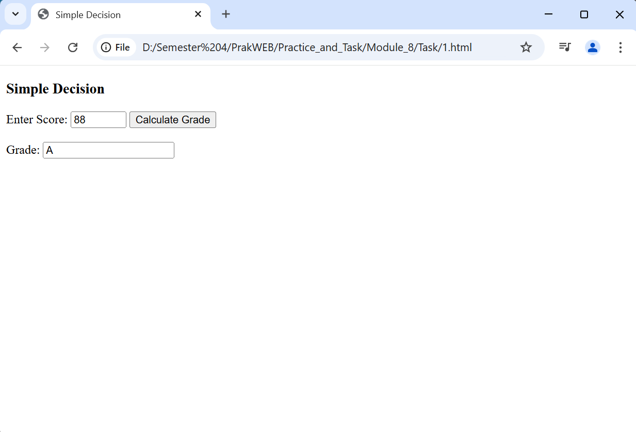

Picture 1.2 assigment output.